Cpu:

HIGH-END:

Intel:

**Cpu:1.Intel Core i9-10900KA Comet Lake 10-Core 3.7 GHz LGA 1200 Special Edition Desktop Processor:10,000 L.E**

2. cpu:Intel Core i9-10850K Comet Lake 10-Core 3.6 GHz LGA 1200 Desktop Processor 7,500.00 EGP

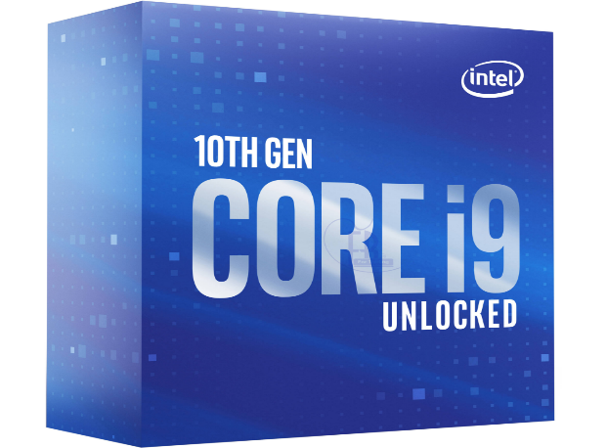

AMD

# 1. cpu: AMD Ryzen 9 3950X 16-Core 3.5 GHz Socket AM4 105W Desktop Processor

13,000.00 EGP

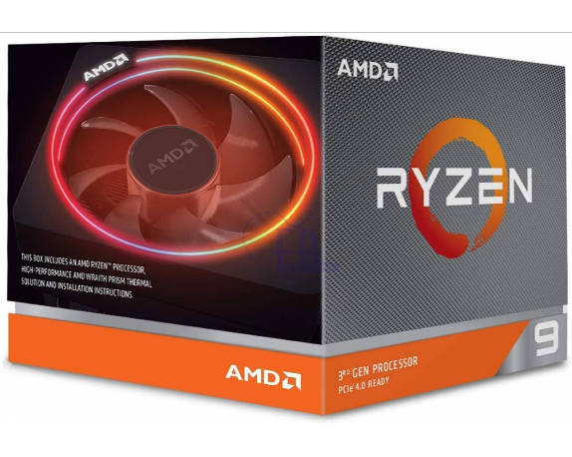

# 2. cpu:AMD Ryzen9 3900XT 12-Core 3.8 GHz Socket AM4 Desktop Processor

9,000.00 EGP

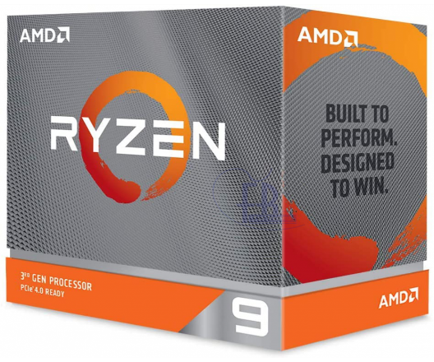

MID

INTEL:

# Cpu:Intel Core i7-10700K Comet Lake 8-Core 3.8 GHz LGA 1200 125W Desktop Processor

6,600.00 EGP

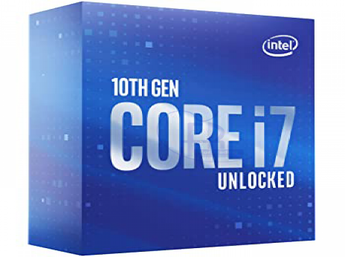

# 2. cpu:Intel Core i5-10600K Comet Lake 6-Core 4.1 GHz LGA 1200 Desktop Processor

4,400.00 EGP

AMD:

# 1.cpu:AMD Ryzen 7 3800XT 8-Core 3.9 GHz Socket AM4 Desktop Processor

6,500.00 EGP

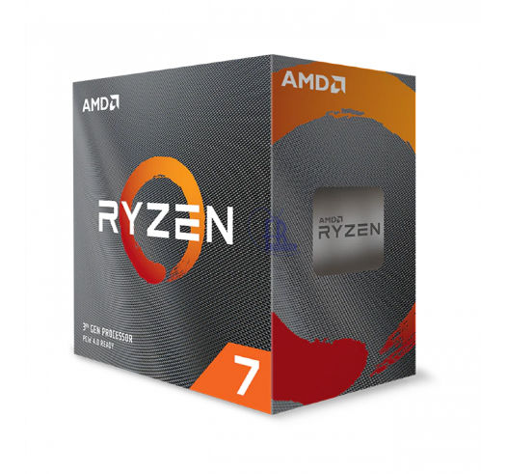

# 2. cpu:AMD RYZEN 5 3600X 6-Core 3.8 GHz (4.4 GHz Max Boost) Socket AM4 95W

4,100.00 EGP

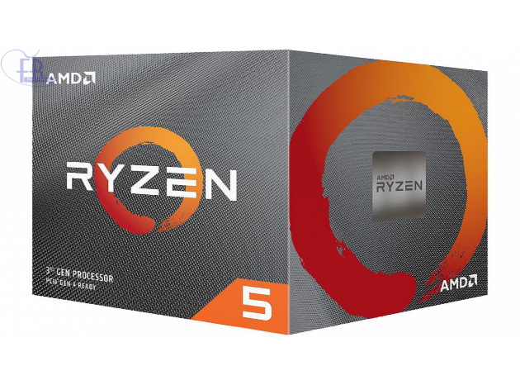

LOW-END:

1.INTEL:

# 1:cpu: Intel Core i5-10400F 6-Core 2.9 GHz LGA 1200 Desktop Processor

2,750.00 EGP

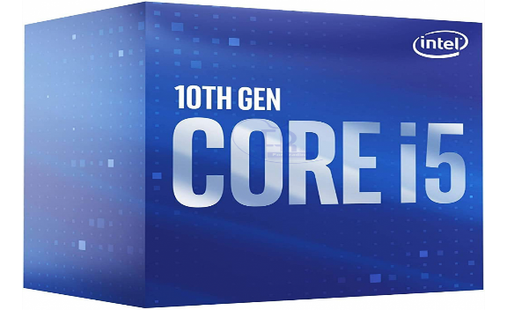

# 2: cpu:Intel Core i3-9100F Coffee Lake 4-Core 3.6 GHz (4.2 GHz Turbo) LGA 1151 (300 Series) 65W Desktop Processor Without Graphics

1,400.00 EGP

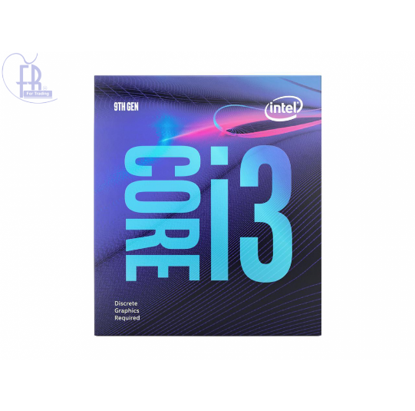

AMD:

# cpu:AMD Ryzen 5 2400G Processor with Radeon RX Vega 11 Graphics

2,200 EGP

# 2. cpu:AMD RYZEN 3 3200G 4-Core 3.6 GHz (4.0 GHz Max Boost) Socket AM4 65W Desktop Processor

1,900 EGP

# GPU

# HIGH-END:

# 1:NVIDIA

# 1: gpu:GIGABYTE AORUS GeForce RTX 2080 Super 8GB GDDR6 GV-N208SAORUS-8GC

15,500.00 EGP

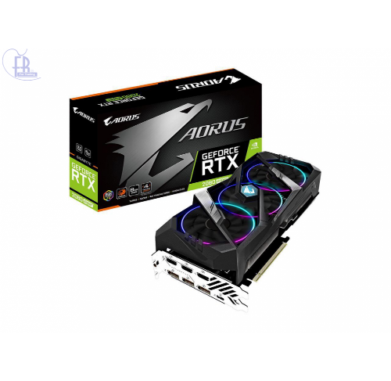

# 2. gpu:MSI GeForce RTX 2070 SUPER GAMING X TRIO 8GB Video Card

11,000.00 EGP

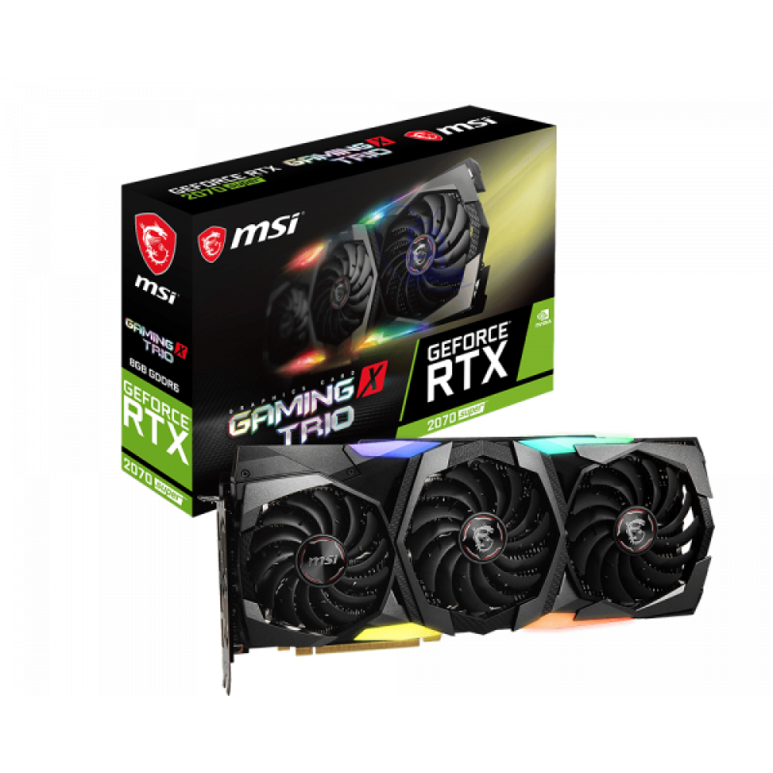

AMD:

# 1:gpu: GIGABYTE AORUS Radeon RX 5700 XT 8G Graphics Card GV-R57XTAORUS-8GD Video Card

9,999.00 EGP

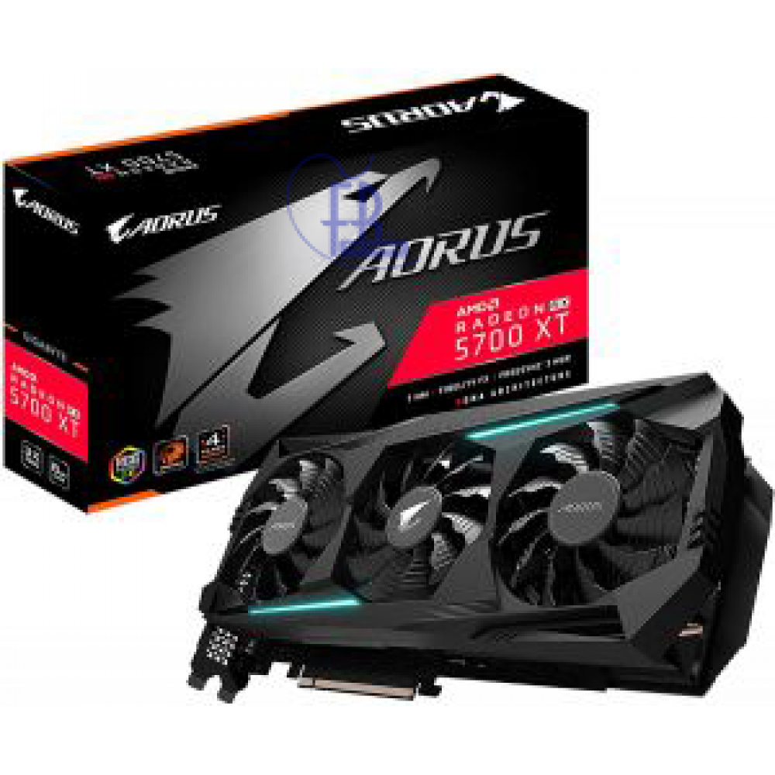

# 2. gpu:MSI Radeon RX 5600 XT MECH OC 6GB

6,300.00 EGP

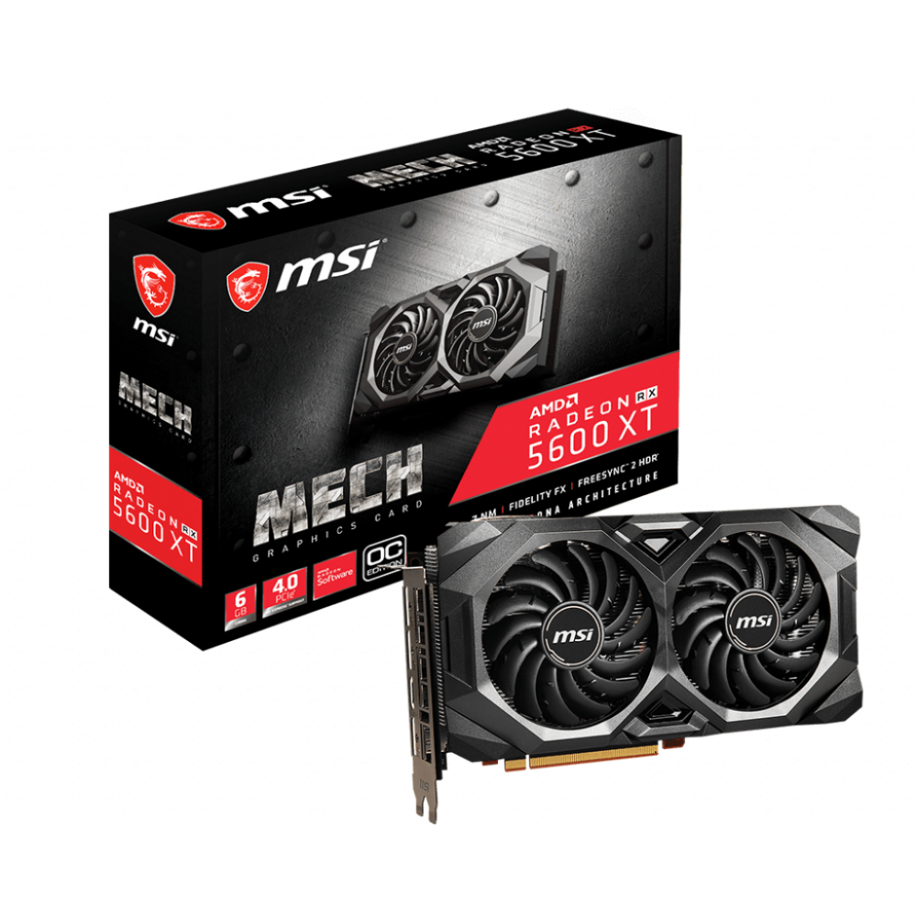

MID

NVIDIA:

# 1: gpu:GIGABYTE GeForce GTX 1660 SUPER 6GB GV-N166SOC-6GD Video Card

5,000.00 EGP

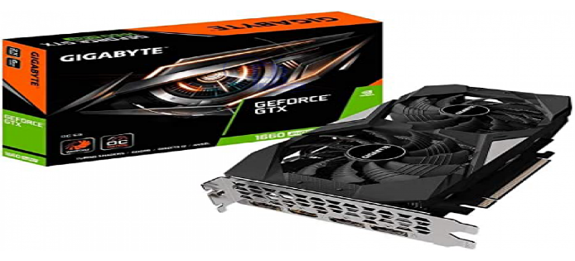

# 2: gpu:MSI GeForce GTX 1650 SUPER Ventus XS OC 4GB Video Card

3,600.00 EGP

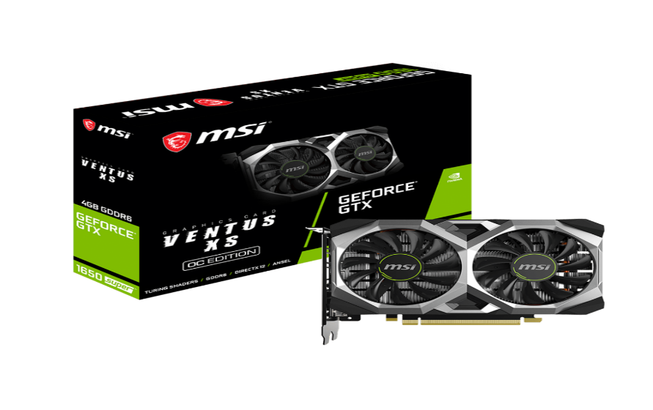

AMD:

1.gpu:GIGABYTE Radeon RX 5500 XT Gaming OC 8G Graphics Card 4,780.00 EGP

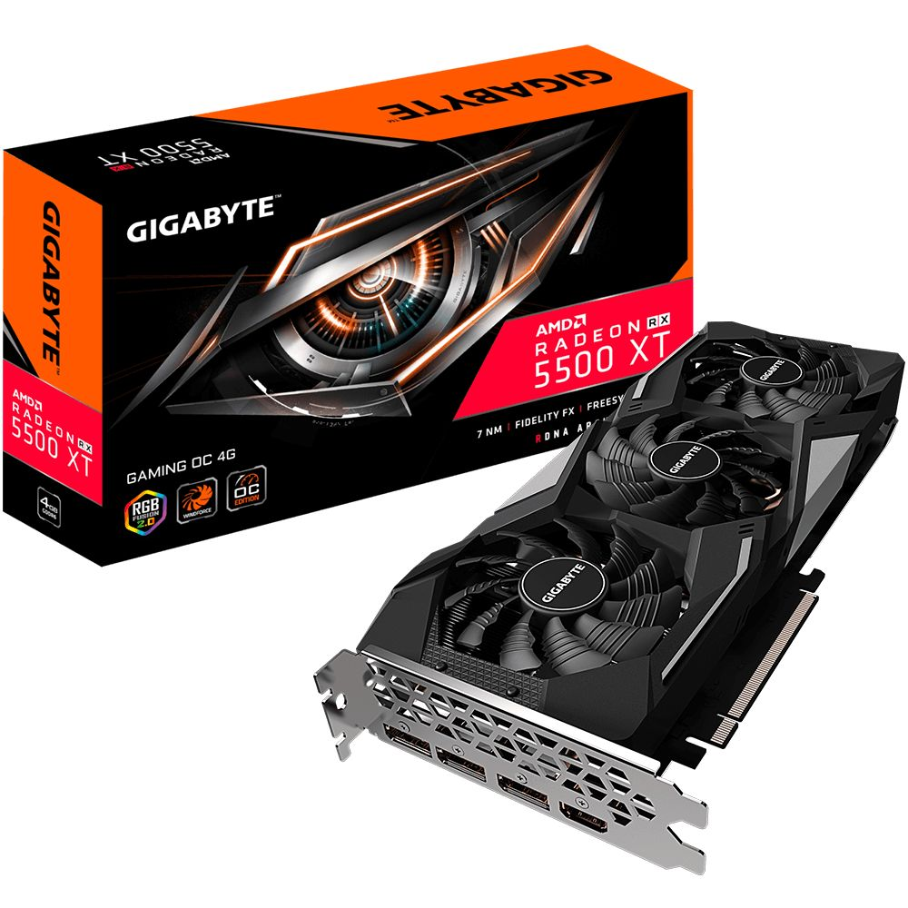

# 2.gpu: Gigabyte Radeon Rx 590 Gaming 8G Graphics Card, 2X Windforce Fans, 8GB 256-Bit GDDR5, Gv-RX590GAMING-8GD Video Card : 6500EPG

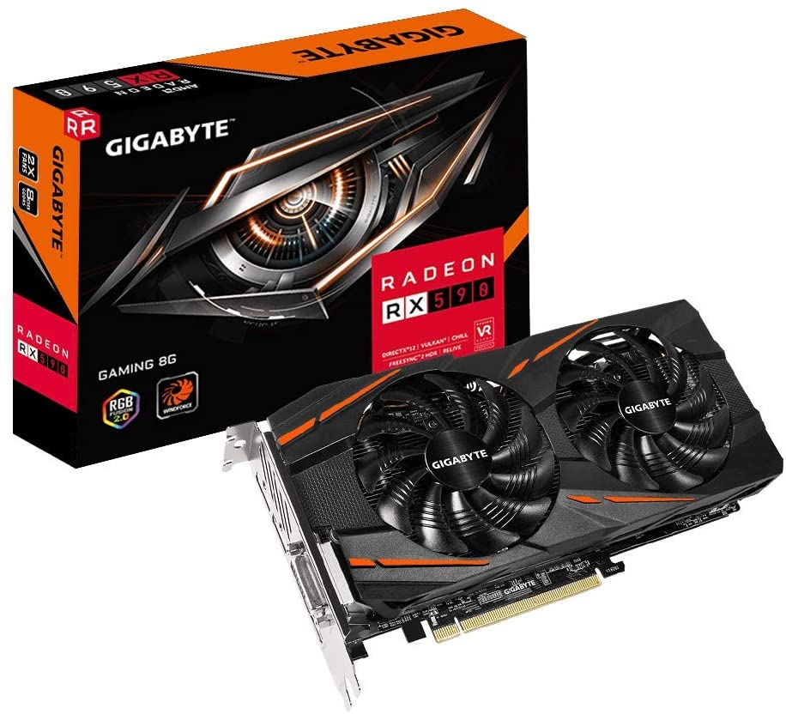

LOW-END

1:NVIDIA

# 1.gpu: GIGABYTE GeForce GTX 1050 Ti DirectX 12 GV-N105TOC-4GD 4GB Video Card

2,800.00 EGP

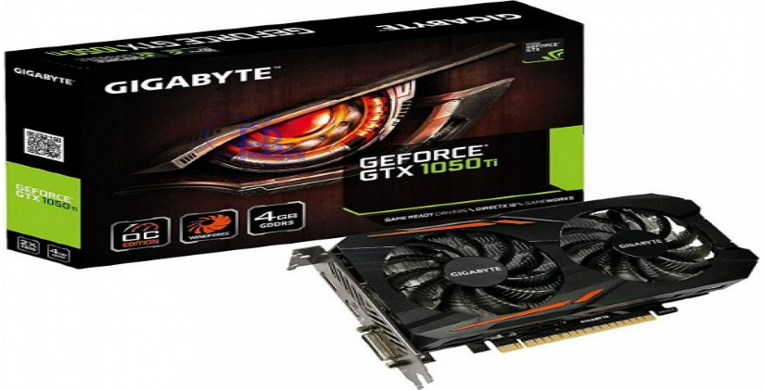

# 2.gpu: MSI GeForce GTX 1650 VENTUS XS 4G OC 4GB Video Card

3,000.00 EGP

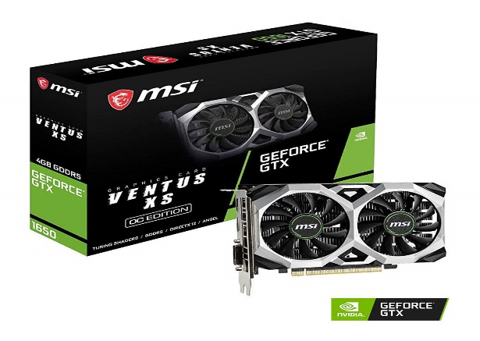

AMD:

1. gpu: GIGABYTE AORUS Radeon RX 580 8GB GDDR5

4,200.00 EGP

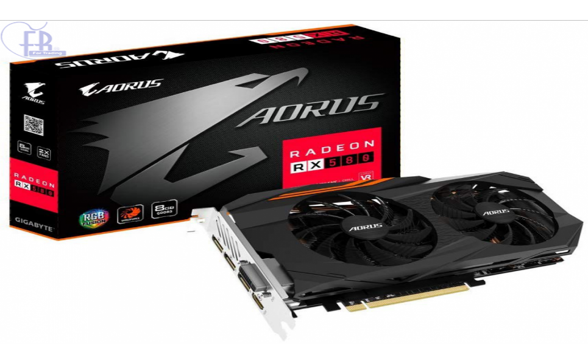

# 2.gpu: MSI Radeon RX 570 GAMING X 4G

### 3,499.00 EGP

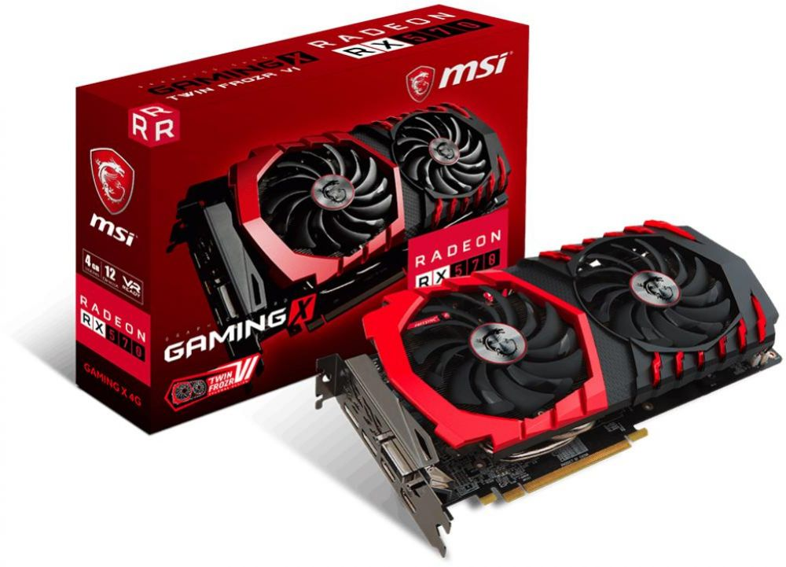

[Motherboards](https://alfrensia.com/index.php?route=product/category&path=204)

HIGH-END

INTEL:

1. [Motherboards](https://alfrensia.com/index.php?route=product/category&path=204)

motherboard Gigabyte Z490 AORUS ULTRA Motherboard 7,100.00 EGP

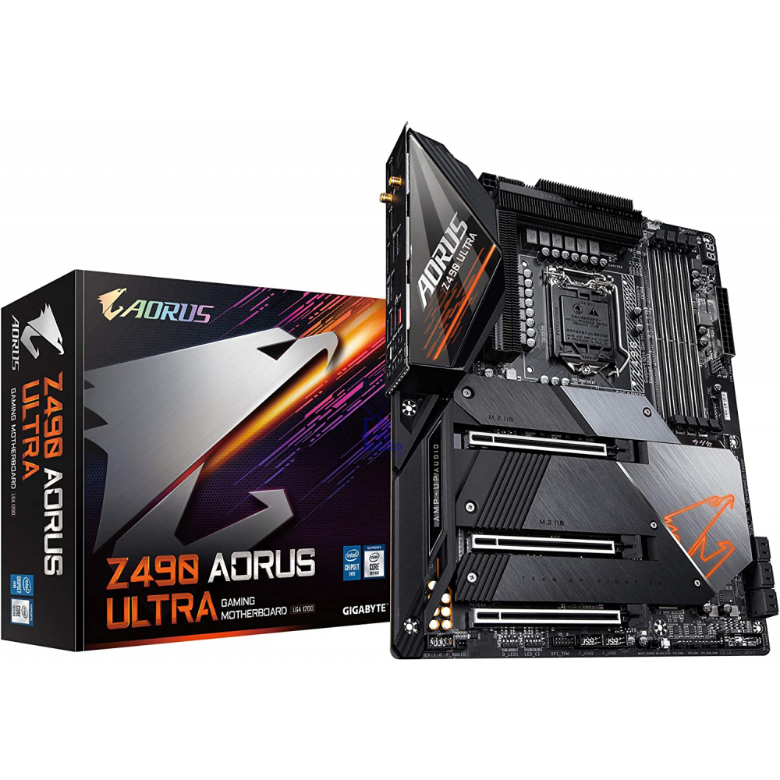

2. [Motherboards](https://alfrensia.com/index.php?route=product/category&path=204)

# motherboard GIGABYTE Z490 AORUS PRO AX

6,200.00 EGP

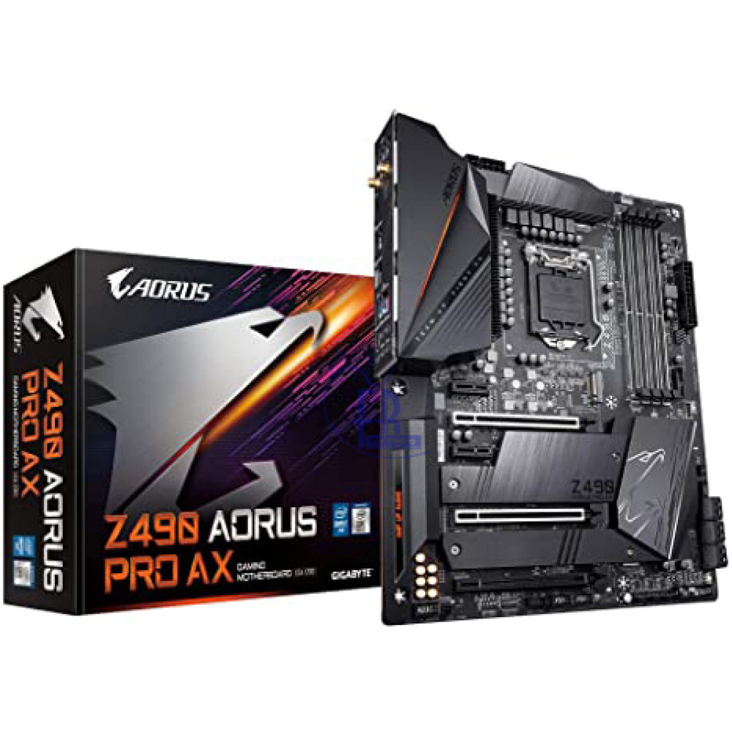

# AMD:

[Motherboards](https://alfrensia.com/index.php?route=product/category&path=204)

# GIGABYTE TRX40 AORUS PRO WIFI

7,700.00 EGP

2. [Motherboards](https://alfrensia.com/index.php?route=product/category&path=204)

# MSI MEG X570 UNIFY AM4 AMD X570 SATA 6Gb/s ATX AMD Motherboard

5,500.00 EGP

# MID

# INTEL

1. [Motherboards](https://alfrensia.com/index.php?route=product/category&path=204)

# GIGABYTE Z490 UD Motherboard

3,100.00 EGP

[Motherboards](https://alfrensia.com/index.php?route=product/category&path=204)

# MSI MAG Z490 TOMAHAWK LGA 1200 Intel Z490 SATA 6Gb/s ATX Intel Motherboard

4,200.00 EGP

# AMD

[Motherboards](https://alfrensia.com/index.php?route=product/category&path=204)

# MSI PRO B550M PRO-VDH WIFI AM4 AMD B550 SATA 6Gb/s Micro ATX AMD Motherboard

3,100.00 EGP

2. [Motherboards](https://alfrensia.com/index.php?route=product/category&path=204)

# MSI PRO B550-A PRO AM4 AMD B550 SATA 6Gb/s ATX AMD Motherboard

2,550.00 EGP

# Low-end

# Intel:

1. [Motherboards](https://alfrensia.com/index.php?route=product/category&path=204)

# GIGABYTE B460 HD3 LGA 1200 INTEL B460 ATX MOTHERBOARD

2,100.00 EGP

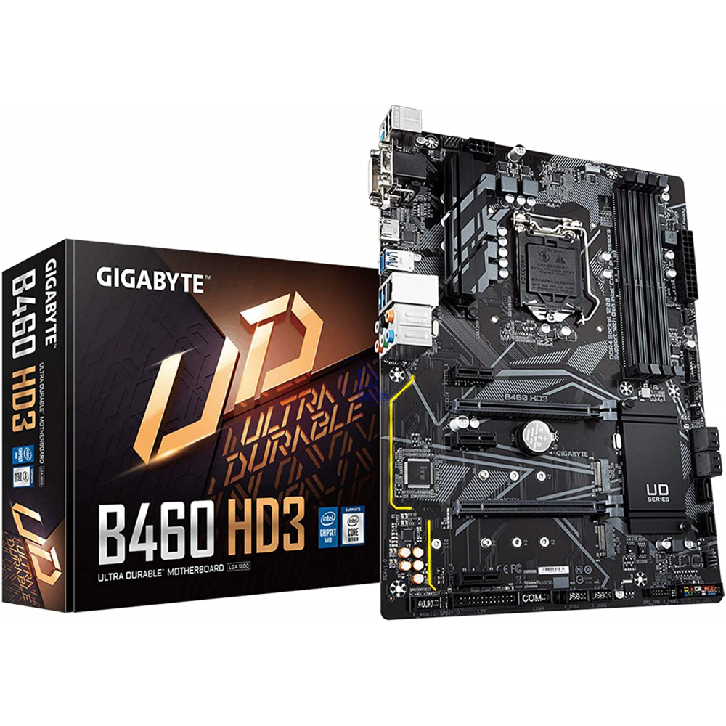

1. [Motherboards](https://alfrensia.com/index.php?route=product/category&path=204)

# GIGABYTE B460M AORUS PRO LGA 1200 Intel B460 Micro-ATX Motherboard

2,000.00 EGP

# AMD:

1. [Motherboards](https://alfrensia.com/index.php?route=product/category&path=204)

# GIGABYTE A520M-DS3H AMD Motherboard

1,550.00 EGP

[Motherboards](https://alfrensia.com/index.php?route=product/category&path=204)

# GIGABYTE B450M DS3H AM4 AMD B450 SATA 6Gb/s Micro ATX AMD Motherboard

1,500.00 EGP

# RAM:

# HIGH-END

1. RAM Gigabyte AORUS RGB 16GB (8GBx2) DDR4 4400MHz

3500EGP

# RAM GIGABYTE AORUS RGB Memory 16GB (2x8GB) RGB DDR4 3600MHz

2,205.00EGP

# MID

# RAM Crucial Ballistix 3600 MHz Gaming Memory

# 1,900.00EGP

# 2. RAM HyperX Fury RGB 16GB DDR4 3200Mhz Memory RAM

1,400.00 EGP

# LOW-END

# 1. RAM HyperX Fury 8GB DDR4 3200Mhz Memory RAM

600.00 EGP

# 2. RAM CORSAIR VENGEANCE LPX 16GB DDR4 3000MHZ

1,250.00 EGP

# MEMORY

# 1.SDD

# 1: ssd SAMSUNG 970 EVO PLUS NVMe M.2 1TB Internal Solid State Drive MZ-V7S1T0BW

3,300.00 EGP

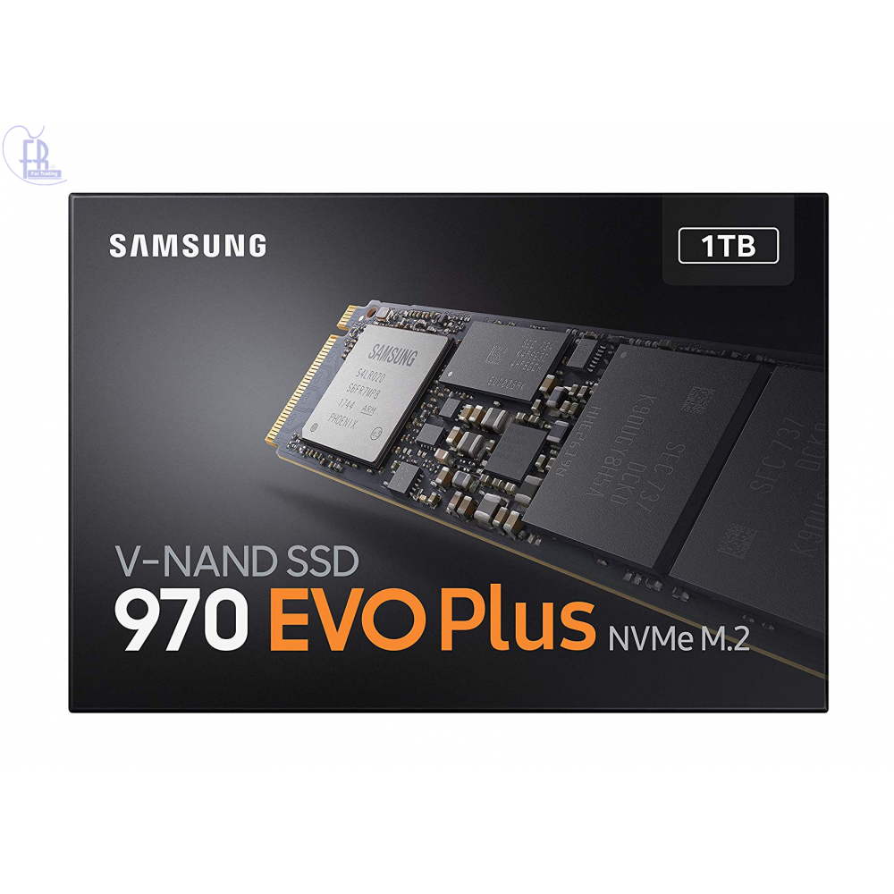

# ssd Crucial MX500 M.2 2280 500GB Internal Solid State Drive SSD

1,200.00 EGP

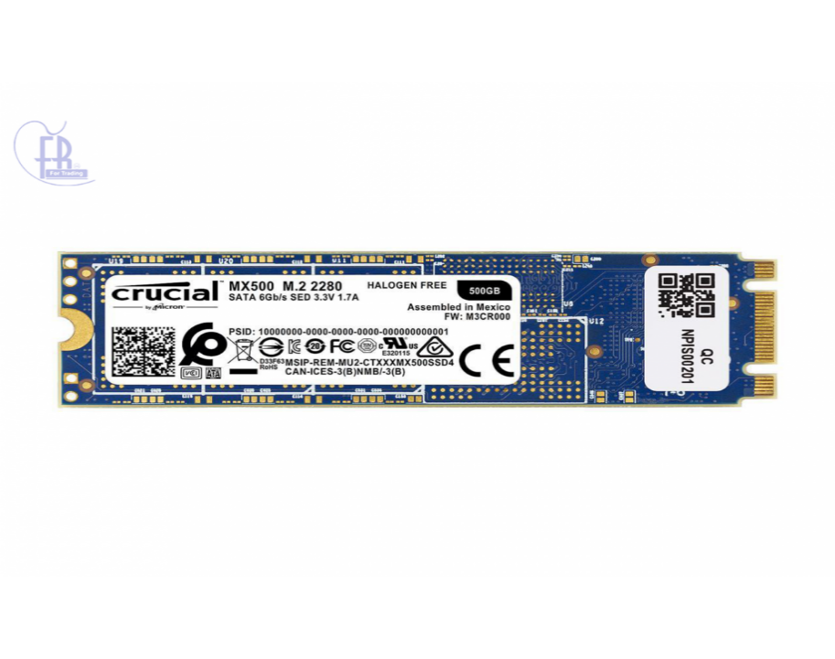

# 3. ssd Lexar NM100 256GB M.2 2280 Solid State Drive

700.00 EGP

# 

# HDD

# HDD

# WD 1TB Blue 7200 RPM Internal Hard Drive WD10EZEX

650.00 EGP

# 

# COOLER:

# COOLER DEEPCOOL Gammaxx L360 V2, AIO Liquid CPU Cooler, Anti-Leak Technology Inside, SYNC RGB Waterblock and RGB Fans

2,200.00 EGP

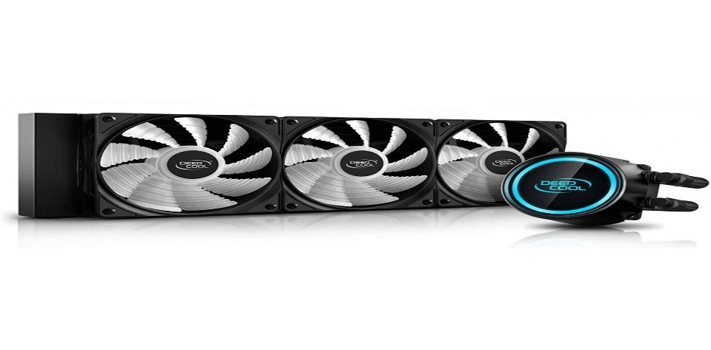

2. COOLER Thermaltake Water 3.0 ARGB Motherboard Sync Edition Intel/AMD 120 All-in-One Liquid Cooling System 1x 120mm High Efficiency Radiator CPU Cooler

1,450.00 EGP

# 3. COOLER Corsair LL120 RGB LED PWM Fan, Single Pack

850.00 EGP

# 

# Power supply

# Power supply

# Gigabyte AORUS P850W 80 Plus GOLD Fully Modular PSU

2,500.00 EGP

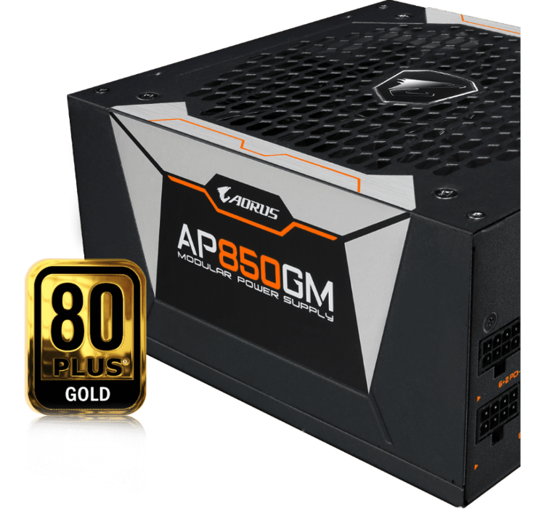

# COOLER MASTER 750W 80 PLUS BRONZE CERTIFIED

1,700.00 EGP

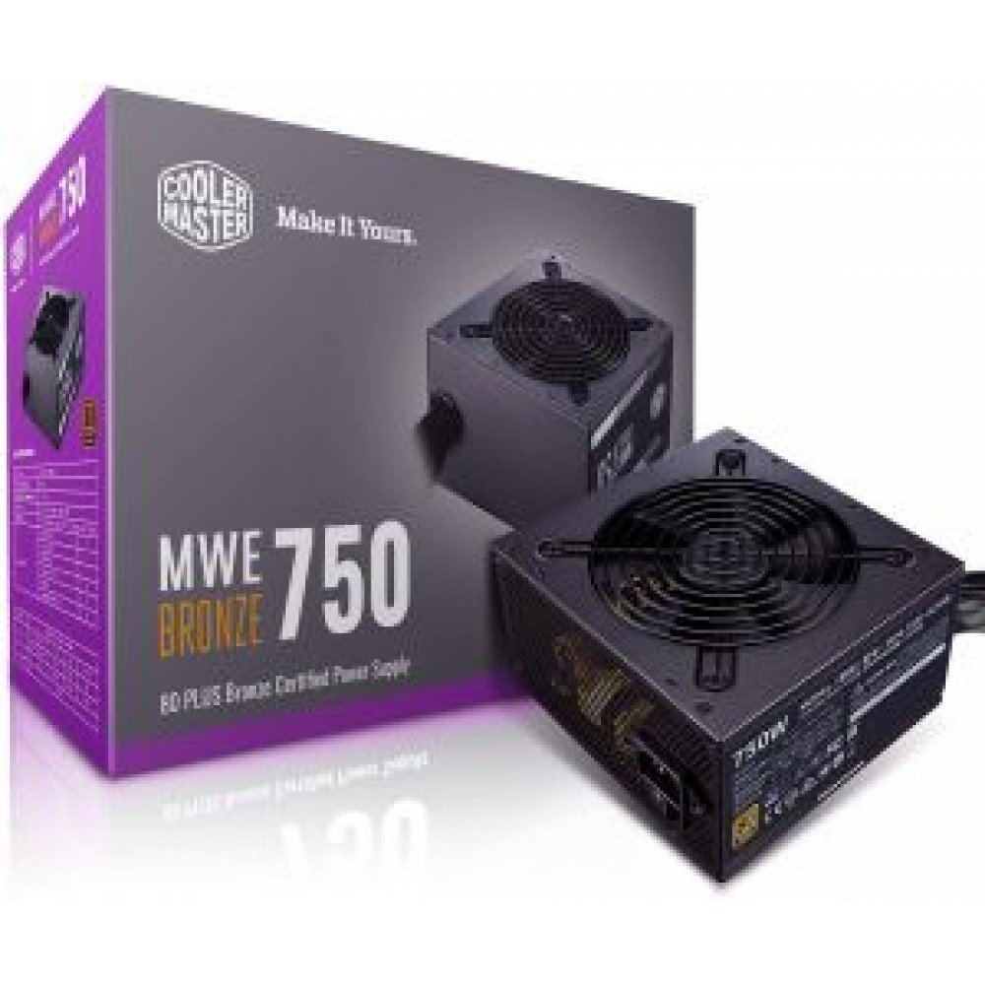

# Power supply

# GIGABYTE P650B GP-P650B 650W 80 PLUS BRONZE Certified Power Supply

1,200.00 EGP

# 